TITLE:

AUTHORS:

ABSTRACT:

Introduction Outline
Paragraph1

Clams are farmed in several countries around the world and account for a large proportion of total global production of shellfish. Like other shellfish species, manila clams are filter feeders and can impact water quality by feeding on micro algae living in the water column. Changing environmental conditions could potentially alter the survival and production of manila clams and therefore have dramatic impacts both economically and ecologically. Manila
clams are sessile organisms with a planktonic larval period lasting for approximately two weeks before the larvae settle in the intertidal region and burrow into the sediment. Studies on manila clam larvae have documented sensitivity to several common environmental stressors such as temperature, salinity, pathogens, and nutrient deprivation (Inoue et al., 2006; Xiwu et al., 2009; Numaguchi et al., 1998; Paillard et al., 2004). Studies regarding the survival and physiological processes affected by ocean acidification have been documented for larvae in other shellfish species such as oysters. However, there are no reports concerning the impact of decreasing pH and changing carbonate chemistry on R. philippinarum larvae.

Paragraph 2
Ocean acidification as a result of anthropogenic carbon emissions is an immediate concern to the health of calcifying organisms.

Ocean acidification is a global problem that threatens to impact shellfish harvests around the world. Recent reports of larval shellfish mortalities in Puget Sound are cause for concern and more information regarding the impacts this could have on commercial shellfish production is needed.

Dissolved pCO2 concentrations in the ocean are influenced by several natural processes. The phenomenon of ocean acidification is a result of increased carbon emissions from industrial practices that occurs through surface seawater mixing where carbon dioxide from the atmosphere equilibrates with the dissolved CO2 of surface seawater. The equilibrated surface seawater can then be pulled down to the deep ocean where it can incubate for several years under high pressure and low temperature. This water later resurfaces during upwelling events such as those documented off the western coast of the United States. Recent reports have observed pCO2 conditions that exceed 1000ppm in upwelled waters.
Upwelled waters off the western coast of the United States have dissolved inorganic CO2 concentrations exceeding the ambient sea level concentrations of 400ppm (Feely 2008). The aragonite levels of this upwelled water are below 1, which is thought to be the threshold level for which calcifying organisms can properly form carbonate structures (Feely 2008). In addition to the influx of corrosive upwelled waters, the carbonate chemistry of estuaries such as Puget Sound are also affected by normal biological processes such as respiration and the decomposition of organic matter. Increases in anthropogenic CO2 emissions only exacerbate the compounding effects of corrosive upwelled waters and biological processes on dissolved pCO2 and aragonite concentrations. Puget Sound, WA represents one of the most productive shellfish growing regions in the United States. Therefore, characterizing the effects of increased pCO2 on larval survival and physiology is necessary to understand the potential impacts ocean acidification will have on this economically important industry.

Carbonate chemistry in the intertidal region such as tide pools and sediments is extremely variable. Clam larvae settle in these environments and are consequently susceptible to changes in carbonate chemistry and potentially tolerable of wide fluctuations.

Paragraph 3
Advances in genomics have allowed for the sequencing and documentation of transcriptional changes in organisms for which there is little genetic information.
Genomics is a powerful tool to observe functional changes in physiological processes impacted by changing environmental conditions.
Understanding physiological responses at the genetic level can provide valuable insight into mechanisms responsible for mortality or those that are used to tolerate stressful conditions.

Paragraph 4
Previous reports have documented _________ thousand new contigs in clams, however these studies were done in a tissue specific manner on only adult organisms. To date, no studies have looked at characterizing the transcriptome of larval clams, specifically the genes involved in developmental processes and stress response (?).
No studies have used NGS to characterize the transcriptome of clams exposed to different pCO2 levels. Several have used microarray technology, but microarrrays require a priori sequence information and are selectively biased on which contigs are represented on the array.
NGS sequencing is an unbiased approach to characterize the whole transcriptome.

Paragraph5
In this study we characterized the transcriptome of larval Manila clams and the genes that are activated during larval development.
We also characterized changes between the transcriptome of clams exposed to ambient and future pCO2 concentrations.

Materials and Methods

Experimental Design
All experimental treatments were conducted at the NOAA’ Northwest Fisheries Science Center (NWFSC) in Seattle, WA. Manipulation of dissolved CO₂ concentrations was achieved by the addition of CO₂ into two independent reservoirs with CO₂ levels monitored using a Licor XXX gas analyzer and controlled using Labview software (XXX). One system maintained near present day (ambient) oceanic sea surface levels of pCO2 (400ppm) and the second system maintained a higher projected level of pCO₂ concentration (1000ppm) to represent acidified conditions. Spectrophotomectric pH was measured on each sampling day in larval chambers within each system. Water samples for total alkalinity and dissolved inorganic carbon were taken on days 3, 5, and 12 and analyzed at the NOAA Pacific Marine Environmental Laboratory (PMEL). Seawater (~30 psu) was collected from Elliot Bay, Seattle, WA, filtered to XX µm, and maintained at 18ºC for the duration of the study.
Venerupis (=Ruditapes) philippinarum (R. philippinarum) larvae were obtained from Taylor Shellfish in Kona, Hawaii. Larvae were evenly distributed in twelve 4.5L CO₂ impermeable chambers at a density of approximately 11 larvae/mL (48,600 larvae/chamber). Larval chambers were placed in the appropriate recirculating seawater treatment system (6 chambers/treatment). Average flow rate for the experiment was 3L/hour. Larval clams were fed a mixture of algae (Nannochloris sp., Chaetoceros muelleri, Isochrysis galbana, and Pavlova lutherii) twice daily at a final concentration of 50,000-80,000 cells/ml. Chambers were cleaned on a semi-weekly schedule that coincided with sampling.

Larval mortality and size analysis
On days 1, 4, 7, 11, and 14 three larval chambers from each treatment were sampled for mortality and size analysis. Larvae were isolated on a 50um screen and two replicate samples of ~50 larvae each were transferred into a 12 well plate. Consecutive sampling of jars between sampling days was avoided to maintain similar larval densities between replicates. Larval mortality was determined by counting the number of dead larvae using an inverted compound microscope at 20x magnification (scope manufacturer?). Subsequently 75% EtOH was added to immobilize live larvae to quantify the total number of larvae per well. Larval size was determined by analyzing photographs taken at 5x magnification with a __________ camera. Total surface area for each larva was calculated using ImageJ. Data collected from replicate samples within a chamber were averaged.

Larvae RNA Isolation
Samples for RNA isolation were taken on day 7 from two chambers in each treatment by isolating larvae on a 50 μm screen. Samples for RNA extraction consisted of ~30,000 larvae from each larval chamber. RNA was isolated using Tri-reagent (Molecular Research Center, Inc., city, state, country) following manufacturer protocols. Equal quantities of total RNA (20µg) from each replicate were pooled in equal quantity for the construction of two transcriptome libraries.

High-throughput sequencing
Library construction and sequencing was performed at the University of Washington High Throughput Genomics Unit (UWHTGU) on the Illumina Hi-seq platform (Illumina inc., San Diego, CA) using standard protocols. CLC Genomics Workbench version 4.0 (CLC bio) was used for all sequence analysis. Initially, sequences were trimmed based on a quality scores of 0.05 (Phred; Ewing, Green, 1998; Ewing et al., 1998) and the number of ambiguous nucleotides (>2 on ends). Sequences smaller than 25 bp were also removed.

RNA-Seq analysis
RNA-Seq analysis was carried out to determine differential gene expression patterns between the two libraries. For RNA-seq analysis RuphiBase, the Manila Clam (Ruditapes philippinarum) transcriptome database (http://compgen.bio.unipd.it/ruphibase/) was used as the reference transcriptome. At the time of analysis this database consisted of 32,606 contiguous sequences (contigs) generated from 454 (Roche) reads (Reference), 5656 Sanger ESTs, and 51 publicly available mRNA sequences. Contigs in RuphiBase are annotated by Gene Ontology and protein (NCBI nr database) BLAST results. RNA-seq analysis was performed using the following parameters; unspecific match limit = 10, maximum number of mismatches = 2, minimum number of reads = 10. Expression values were measured in RPKM (reads per kilobase of exon model per million mapped reads; see Mortazavi et al., 2008). Differentially expressed genes were identified as having > 2 fold change between libraries and a p-value <0.1 (Baggerly et al., 2003). Hypergeometric tests on annotations was performed to identify enriched biological themes in the differentially expressed genes as compared to the whole transcriptome. This test procedure was performed using CLC Genomics Workbench V4.0 and is similar to the unconditional GOstats test of Falcon and Gentleman, 2007. Significantly enriched (p<0.01) GO terms and their associated p-values were uploaded to REViGO (Reduce + Visualize Gene Ontology http://revigo.irb.hr/) for visualization.

Results
Results

Water Chemistry
Water treatment conditions for ambient and elevated pCO2 equilibrated water are summarized in Table 1. Ambient conditions were maintained at 355.04 μatm +/- 16.85 with a pH of 8.07 +/- .02. These values are consistent with the current sea surface pCO2 conditions. The elevated conditions maintained pCO2 levels of 897 μatm +/- 47.61SD with a pH of 7.71 +/- .02SD which is representative of projected sea surface conditions but is also similar to pCO2 conditions in areas influenced by upwelling events such as those found in hood canal and Puget Sound, WA. Manipulation of pCO2 conditions was efficient in driving down the saturation state of aragonite and calcite. Aragonite levels dropped from 3.63 in the ambient treatment to 1.12 in the elevated pCO2 treatment, a value just above the critical saturation level for calcification of 1. Similarly, the concentration of calcite decreased from 3.63 in ambient to 1.76 in the elevated pCO2 treatment.

Table1
Summary of water chemistry measurements for ambient and elevated pCO2 treatments +SD

Larval growth and survival
There was no detectable effect of elevated pCO2 conditions on R. philippinarum growth and survival (figure x). Larval shell size increased steadily in both treatments over the course of the experiment. Larval survival was not statistically different between treatments, however there was a slight trend of increased survival in the elevated pCO2 conditions. There was also a trend from days one through seven where larvae in ambient pCO2 conditions appear to be growing at a faster rate but the trend diminishes by day 11.
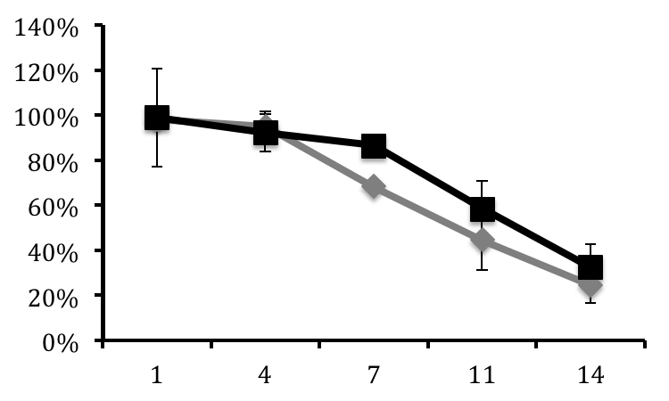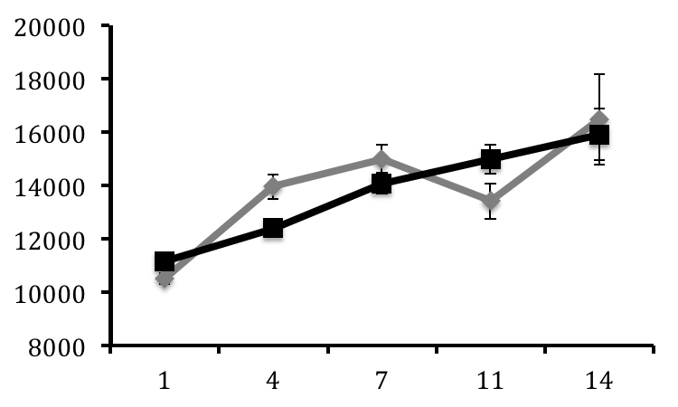

Figure 1
Percent larval survival at ambient (diamonds) and high (triangles) pCO2 conditions on days 1, 4, 7, 11, and 14 +/- SE (n=3/day).

Illumina Sequencing

Sequencing of the R.philippinarum larval transcriptome yielded a total of 175,724,967 and 68,062,722 reads from the ambient and acidified libraries, respectively. All data are available in the NCBI Short Read Archive database (Accession # XXXXXX). After quality trimming, 146,019,873 and 67,691,220 reads remained from the ambient and acidified libraries, respectively, with an overall average length of 36 bp.

RNAseq analysis
Expression analysis by RNAseq resulted in 57,985,294 (39.7%) reads from the ambient transcriptome library, and 26,075,212 (38.5%) reads from elevated pCO2 transcriptome library mapping to the 32,606 contigs from the RuphiBase transcriptome database. Among the reads from the ambient library that mapped, 47,210,547 (81.4%) mapped to a single contig while 19,397,495 reads (74.4%) from the elevated pCO2 treatment library mapped to a single contig. Among the contigs identified in the ambient and elevated pCO2 libraries, 781 contigs were differentially regulated with a fold change >1.5 (p<0.1) (Supplemental Table 1). Analysis of significantly enriched GO terms from the population of significantly regulated contigs revealed 116 unique biological processes. The most represented processes are translation, rRNA processing, protein targeting, embryo development, hydrogen peroxide catabolism, mitotic cell cycle G1/S transition checkpoint, and microtubule-based movement. Other significantly represented process include purine nucleotide transport, protein targeting, ATP synthesis coupled proton transport, gene expression, positive regulation of nitric oxide biosynthesis, retinoic acid metabolism, erythrocyte homeostasis, , ER-associated protein catabolism, microtubule-based process, reproduction, respiratory electron transport chain, and (Figure X). The genes associated with these biological processes are highlighted (*) in supplemental table 1.

Of particular interest to this study are genes involved in calcification and proton transport. While not identified as an enriched biological process, Perlucin-6, a gene involved in nucleation of calcium carbonate ions during shell formation, was significantly elevated (133 fold) in the high pCO2 treament library. Interestingly, genes that are involved in several vital cellular processes that rely on calcium binding activity to function properly were also induced in the larvae exposed to elevated pCO2 conditions. These genes include calmodulin, calreticulin, proteins containing EF-hand motifs such as sarcoplasmic calcium-binding protein and the calcium-binding ef-hand domain protein, myosin alkali light chain 1, and voltage-dependent anion channel 1.

While stress response was not identified as a biological process that is significantly regulated, genes involved in stress response are of interest when monitoring physiological changes to environmental stress. Molecular chaperones heat shock protein 70 and 90 are commonly used as indicators of stress and both are induced in the larvae exposed to elevated pCO2. Genes involved in response to oxidative stress, including thioredoxin and glutathione peroxidase 3 were also observed to be induced in larvae exposed to elevated pCO2.

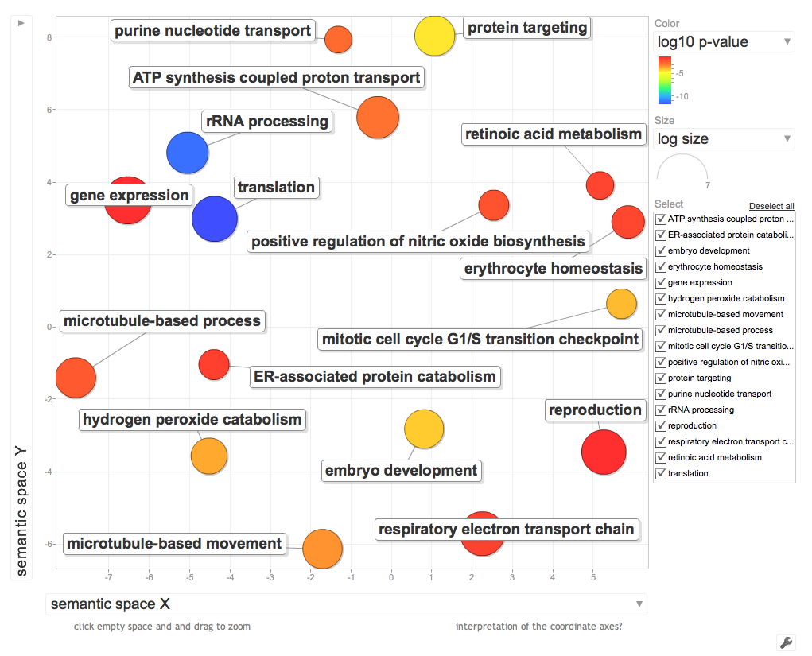

Figure 2
Visualization of enriched GO processes identified from significantly regulated genes. Distance between processes represents relatedness while size of the circles is represents –log10 p-value of the GO term enrichment.

